## horizontal line



Clermont Safety

04.25.2017

**─**

Clermont Crew

CS 4590 Semester Project

Dr. Maribeth Gandy

Georgia Institute of Technology

# Team Members and Contributions

|  |  |
| --- | --- |
| Name | Contributions |
| Daniel Ansher | Filmed vision and final videos, edit final simulation video, co-designed wire scenario |
| Marcus Bolden | Co-design ladder scenario, sound master for videos |
| Tiera Lee | Coordinate and dictate Interviews, create evaluation questionnaire, co-design wire scenario |
| Rob Townsend | Co-design ladder scenario, edit vision video |

# Overview and Idea Process

Clermont Safety is a design and evaluation project created for the purpose of giving maintenance workers situational awareness through through sound. The wearable technology aims to tackle issues for maintenance workers who need to be aware of their physical environment at all times in order to keep themselves and the general population safe. Surrounding people often disregard safety barriers and as a result, our audio-centric solution would improve physical hazard detection in new areas of low visibility, crawl spaces, and high student traffic. This includes the activities such as detecting a voltage short between wires, tracking an electric current through a wall, detecting voltage values within a junction box, and alerting pedestrians of a worker on a ladder.

We initially interviewed 5 maintenance workers about their working environment, and the kind of information that is needed to perform their jobs safely and efficiently. They gave us general overviews of their daily work and presented potential scenarios that we could work with. We introduced various potential initial sounds to use for our product.

# Prototypes

## Version 1

In our second interview, the workers narrowed scope to propose three main scenarios for us to tackle: being in an environment above 85 dB, working on a ladder with students and faculty walking by, and working in a manhole with students walking by. The ladder scenario focuses on being inside, while the manhole scenario focused on being outside.

### Decibel Scenario

Throughout the second interview, the maintenance workers stressed the fact that the sound should be loud and alarming, especially since they would be working in areas of high volume. We needed to take into account that the room would be noisy and that the user may have ear protectors on while performing their duties. After we introduced demo sounds to the workers, they decided that the strongest one was a long and flaring alarm sound. Every time the worker would enter an environment that reached above 85 dB, this alerting sound would repeat constantly until the environment noise reduced itself to below 85 dB. The higher the dB level, the quicker the sound would repeat itself.

### Ladder Scenario

For the ladder scenario, the goal was to use a sound that was not distracting (since the environment would be inside), and effective enough for students to move out of the way when hearing it. For the first version of our design for this scenario, there was a button that would play the sound if it was pressed. Additionally, there was a slider from 0-10m. If the slider was changed to anywhere below or equal to 3m, the notification sound would repeat until the slide value was increased to 4 or above. The notification sound was a loud buzzer that could have been distracting, but was definitely obtrusive enough to get students to move out of the way.

### Manhole Scenario

For the manhole, the workers needed a loud sound that would be able to be heard over outside noises associated with a college campus. This includes cars passing by, people talking, and small animals. The alert sound designed was loud, with a strong vibrato of medium frequency that sounded out of place. It sounded almost like a goat. This was designed to capture the attention of anyone who walked too close to the working area, and notify the worker as well. As a person walked closed and closer, the tempo of the alert sound would increase.

## Version 2

After our midterm evaluation, it was decided that our scenarios were not sophisticated enough, and that using sound was not appropriate for alerting workers of an environment that is above 85 dB. After interviewing the workers again, we decided to focus on making the “worker on a ladder” scenario more sophisticated, and create a system that helped electricians find faulty wires in the wall more efficiently.

### 

### Ladder Scenario

For version 2 of the ladder scenario design, we needed to make the design more sophisticated. There needed to be more sonification. We chose to use four sounds in a “family” for our new approach. The family idea was inspired by the Sidekick case study shown in class. Our chosen family of sounds was bell sounds. Each sound had a different tone color and was mixed in FL Studio to roughly the same volume. Also, equalizers were used to get rid of muddy bass tones and add to their distinctive timbre. The four sounds were to be used to dictate if a student was approaching the ladder from the front left, front right, back left, or back right. One sound was used for each of the four directions. The directions were from 0-89 degrees, 90-179 degrees, 180-269 degrees, and 270-359 degrees (unit circle split in fourths). Panning was also used and changed iteratively depending on the angle of the approaching student. We increased the volume for an increasing density of students approaching from each direction. Lastly, the sounds loop and the loop speeds up as the student(s) get closer.

### Faulty Wire Scenario

For the faulty wire scenario, we broke it into two functions. Finding faulty wires in junction boxes and power sources behind a wall. A junction box is a simple container on a wall that houses wires that come together at one. Traditionally when a worker works on the a junction box, they must test each wire individually first to see if it is live or not. Then they must to test to read the voltages of each wire again. For testing a wire through a wall, workers often must tear down a wall where they think a problem is and test the voltages again. Workers must also be aware of what colors the wires are because wires are associated with a particular usage of the wire and can only be connected in certain ways. For example, red wires can only connect to other red and black wires, but never blue wires.

We designed to read wire voltages in a four-way junction box, which pulls wires from the up, down, left, and right, directions. Our device utilized spacial-sound to sonify notifications in these directions. For example, a sound coming from the left wire will sound like it’s coming from the left side of the device. The notification sound will be two possible choices that are played dynamically. The first option is a heartbeat monitor noise that increases in tempo and frequency as the voltage in a wire increases. The more a worker uses the device they will be able to understand what is an expected heartbeat for that particular room. The second notification sound is the “flat line” noise associated with a heart that has stopped beating. This represents a wire with no voltage going through it.

Finding the power source of a wire in a wall builds upon this idea of the tempo changes to convey new information. The idea is for the worker to be able to trace a wire through a wall so they can find its source without tearing the wall apart. We associated a 5 common wire colors with 5 notes on a piano, tempo ranges to determine how close they are to the power source of a wire, and a flatline to indicate that there is no voltage, meaning they lost the wire. These ranges are indicated in the following tables.

**Clermont Safety Wire Color Notes**

|  |  |
| --- | --- |
| Note | Wire Color |
| Middle C | Black |
| Middle D | Red |
| Middle E | White |
| Middle A | Yellow |
| Middle B | Green |

**Clermont Safety Source Distance Tempos**

|  |  |
| --- | --- |
| Tempo (beats/ min) | Distance Range (feet) |
| Flatline | No Current Reading |
| 20 | Ft > 5.0 |
| 40 | 5 <= ft <= 3 |
| 80 | 3<= ft <=1 |
| 160 | 0 <= ft <= 1 |

## Version 3

Based on feedback from the students, we concluded that the goat noise from version 1’s manhole scenario would be the best fitting sound for the ladder scenario. It’s obtrusive enough to get the students’ attention, and can still be heard at relatively low volumes. It’s important to be careful with max volume since the ladder scenario wa designed for inside work. The bell sounds were deleted and the goat sound was added for all student approach directions. The sound still repeats faster as the students approach, and panning is still based on direction.

# Implementation and Evaluation

## Film

For our project vision video, we wanted to highlight the main benefits with using Clermont Safety. As a result, each scenario focused on two takes: one with the user task without the tool and a second take utilizing the tool for the user’s benefit. This contrast directly shows viewers how the tool could benefit users from a promotional aspect. With regard to the simulations, we wanted to capture the maintenance workers’ and Georgia Tech students’ natural reactions to the tool. Where the vision video aimed to show what the perfect product would look like and how to “sell” the product, the simulation was filmed in a way that was for research, where as a team, we could examine student reactions to sounds, ask them about the sounds, and rework them for the future. We could also see how the maintenance workers use our prototype tool, and understand what kinds of gestures and movements a maintenance worker would make when using the tool.

For the vision video, we asked a student to act as a maintenance worker. This student went through each scenario illustrating what life would be like as a worker without Clermont Safety and then how Clermont Safety has aided his daily experience. For the simulation video, we asked two random students to walk by a ladder various times with different sounds. We made note of which were more effective based on the reactions of the students. Then, we allowed another maintenance worker pretend to open a junction box and measure the voltage of wires coming from different directions. This scenario was effective and intuitive for the worker. Lastly, the same maintenance worker tracked the voltage of a wire within the wall, explaining after how much quicker and easier the process was with this tool instead of the traditional troubleshooting steps.

## Evaluation

### Faulty Wire Scenario

The task of finding a faulty wire through a junction box takes on average an hour, but workers claimed our system can take it down to about three minutes. This is a 95% reduction in time. On a scale of 1 to 10, workers rater our system a 10 while the current process was only rated a 2.5. Tracing a wire through a wall can take around two hours, but our system reduced this to about 25 minutes. This is an 80% reduction in time. Again, the our system was rated a 10, while the current process is rated at a 2.5. Our device has the added bonus of not only making the facilities worker’s job easier, but preventing unnecessary work for carpenter and painters.

### Faulty Wire Scenario

Currently there is no system in place to alert distracted students or workers that the student in encroaching on a dangerous workplace. It is helpful for the students to hear the alert frequency and tempo change as the student changed their location relative to the work area. The version with the alarming “goat” noise, that increased in tempo as the student got closer to the work area, captured the attention of the student best. They looked and tried to find the source of the sound, to realize that it’s coming from the ladder, thus realizing a worker was there. Our system had a 50% success rate in getting students to look up from their phones to notice workers on ladders. Our system was given an average rating of 7 for effectiveness from students.

# Soundboard Instructions & Use

We created a Soundboard that we used during our simulations. The project source code is on Github [here](https://github.com/RobTownsend/cs4590_soundboard).

**To Use:**

1. Download ZIP file from Github & Unzip
2. open soundBoard.pde using Processing
3. Click Run

**Troubleshooting:**

* Make sure your soundBoard.pde file is within the soundBoard folder.
* Make sure you have all of the sound files in the data folder of your project.

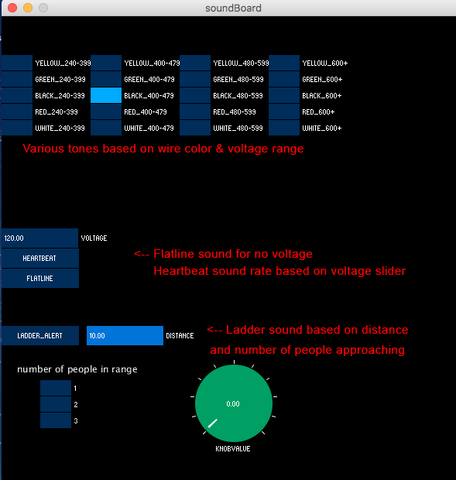

# Deliverable Appendix

* **Clermont Crew Pitch**
* **Work Plan**
* **Project Report**
  + Project Report Doc
  + Project Report Presentation
* [**Soundboard Source Code.zip**](https://github.com/RobTownsend/cs4590_soundboard)
  + [soundBoard.pde](https://github.com/RobTownsend/cs4590_soundboard/blob/master/soundBoard/soundBoard.pde)
  + [ladder_scenario.pde](https://github.com/RobTownsend/cs4590_soundboard/blob/master/soundBoard/ladder_scenario.pde)
  + [helper_functions.pde](https://github.com/RobTownsend/cs4590_soundboard/blob/master/soundBoard/helper_functions.pde)
  + [data](https://github.com/RobTownsend/cs4590_soundboard/tree/master/soundBoard/data)
* **Project Sounds**
  + Decibel Scenario
  + Heart Sounds
  + Ladder Scenario
  + Manhole Scenario
  + Misc
* **Clermont Safety Vision Video**
* **Clermont Safety Simulation**
* **Possible User Scenarios**
  + Locating Wire In Wall User Scenario
  + Cistern User Scenario
  + Methane/Propane Gas Detection User Scenario
  + Ladder Spatial Awareness
* **Interview Notes**
  + Maintenance Meeting 1 Notes
  + Maintenance Meeting 2 Notes
  + Simulation Participants Notes
  + Facilities Management Meeting Audio
  + Simulation Reaction
  + Work Scenario Interview
  + Initial User interview
* **Final Report**